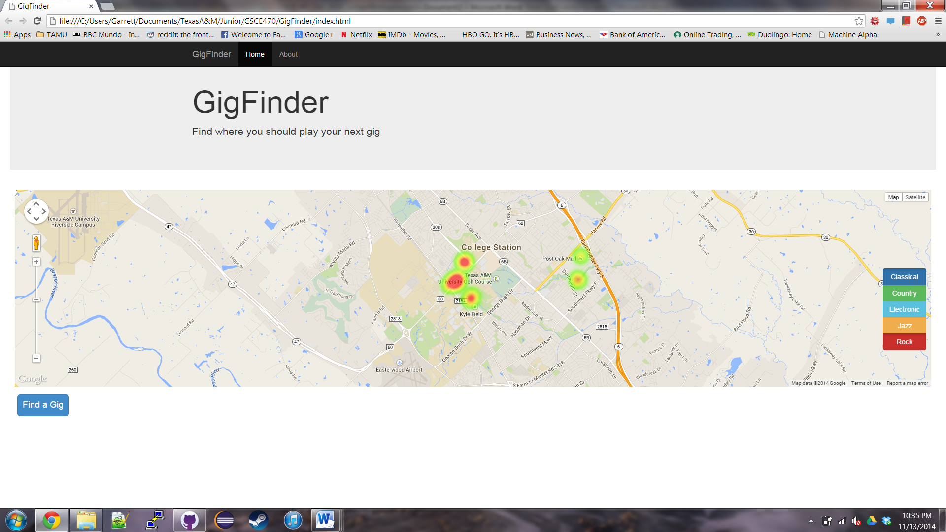

This screenshot shows the map with some fake data displayed as a heat map.

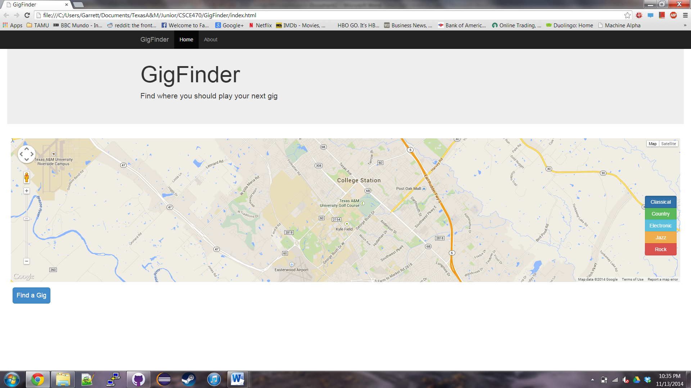

This screenshot shows the map with rock music turned off.

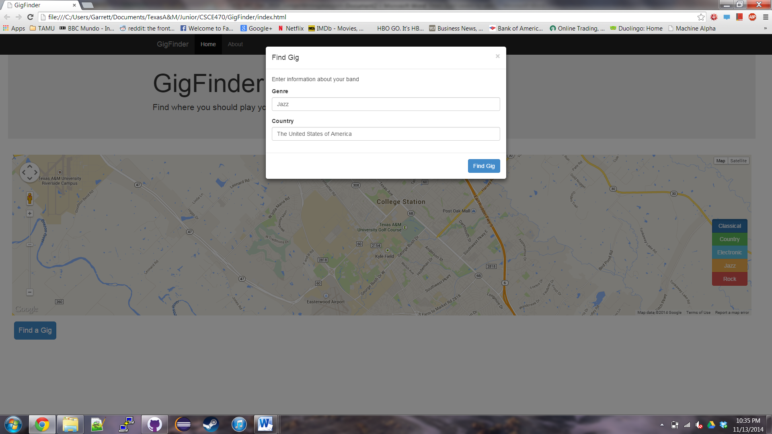

This is a screenshot of the popup used to enter the user data.

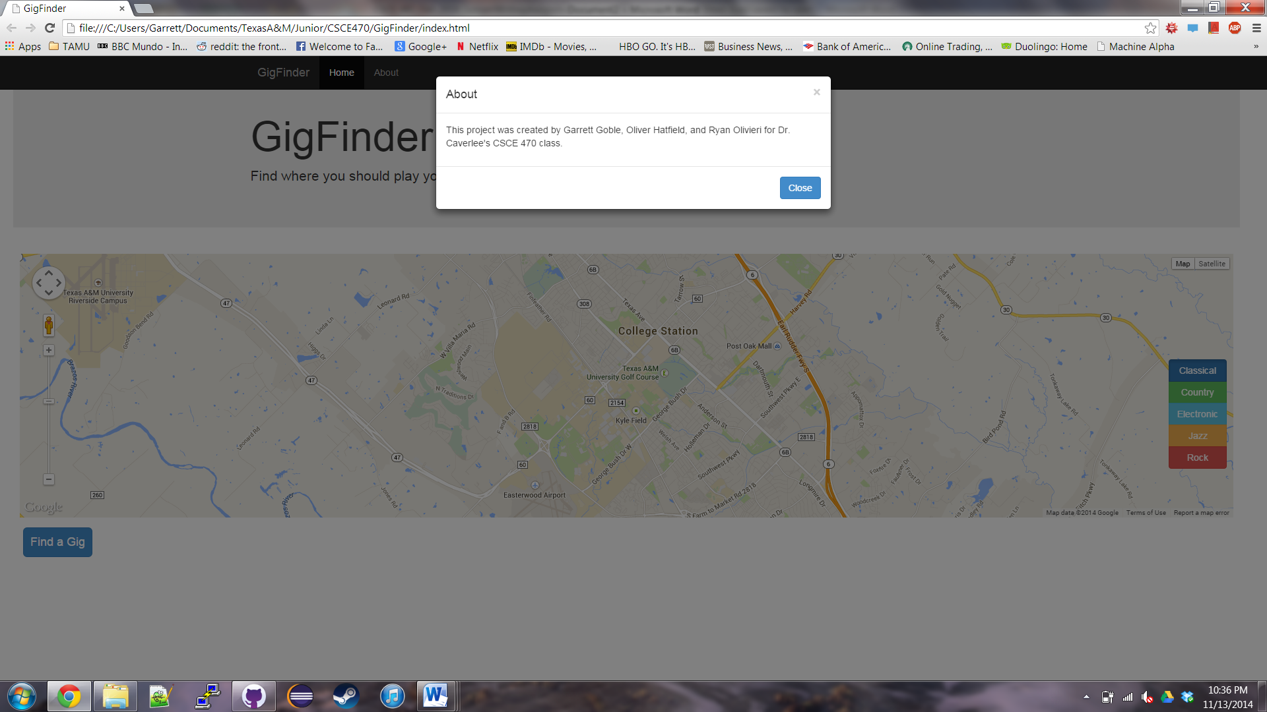

This screenshot shows the popup with information about the project and our team.